VIRTUAL PRIVATE CLOUD (VPC)

VPC : A VPC gives you full control over your virtual networking environment, including selecting your own IP address ranges, creating subnets, and configuring route tables and network gateways.

Key components of an Amazon VPC include:

* Subnets : Segments of a VPC's IP address range.
* Route tables : Sets of rules that determine where network traffic is directed.
* Internet gateway : Allows communication between your VPC and the public internet.
* NAT gateway : Enables instances in a private subnet to connect to the internet while remaining protected from inbound internet traffic.
* Security groups and Network Access Control Lists (ACLs) : These act as virtual firewalls to control traffic to and from your resources.

How to create VPC?

* 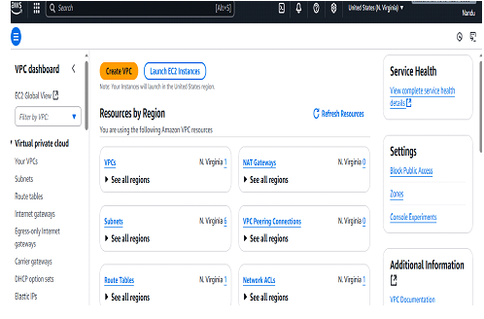 Go to <https://aws.amazon.com>.
* Sign into console enter your password and email id then the page is open.
* Then the page is open .
* Search for vpc in search bar then VPC dashboard open.
* Click on create VPC.
* Resource to create : VPC only
* Name :Myvpc1
* Choose IPV4 CIDR block.
* Mention that tag name then click on create .

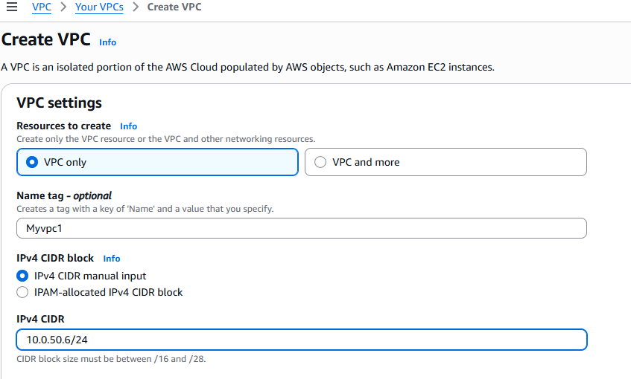 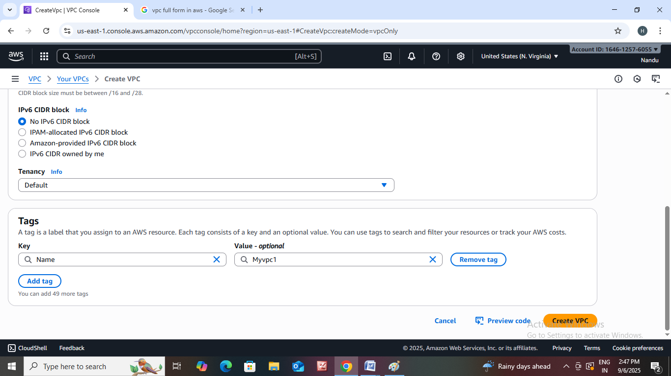

* 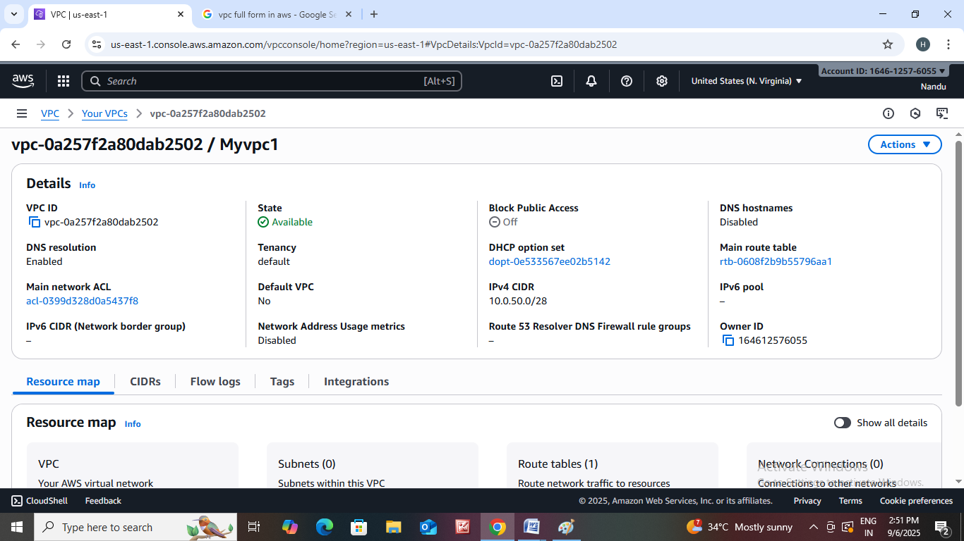 Then VPC is created.
* We didn’t create any subnets so its showing 0 subnets in resource map.

Let us onboard one practical example.

USERS PROJECT- VPC

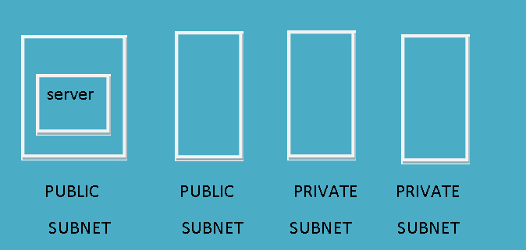

* Go to <https://aws.amazon.com>.
* Sign into console enter your password and email id then the page is open.
* Then the page is open .
* Search for vpc in search bar then VPC dashboard open.
* Click on create VPC.
* Resource to create : VPC and more.
* Name : projectvpc
* Enter that IPV4 :10.0.60.0/16

# 

* Select how many no of availability zones you want.
* Select that how many no of public and private subnets you want.
* Then click on create.

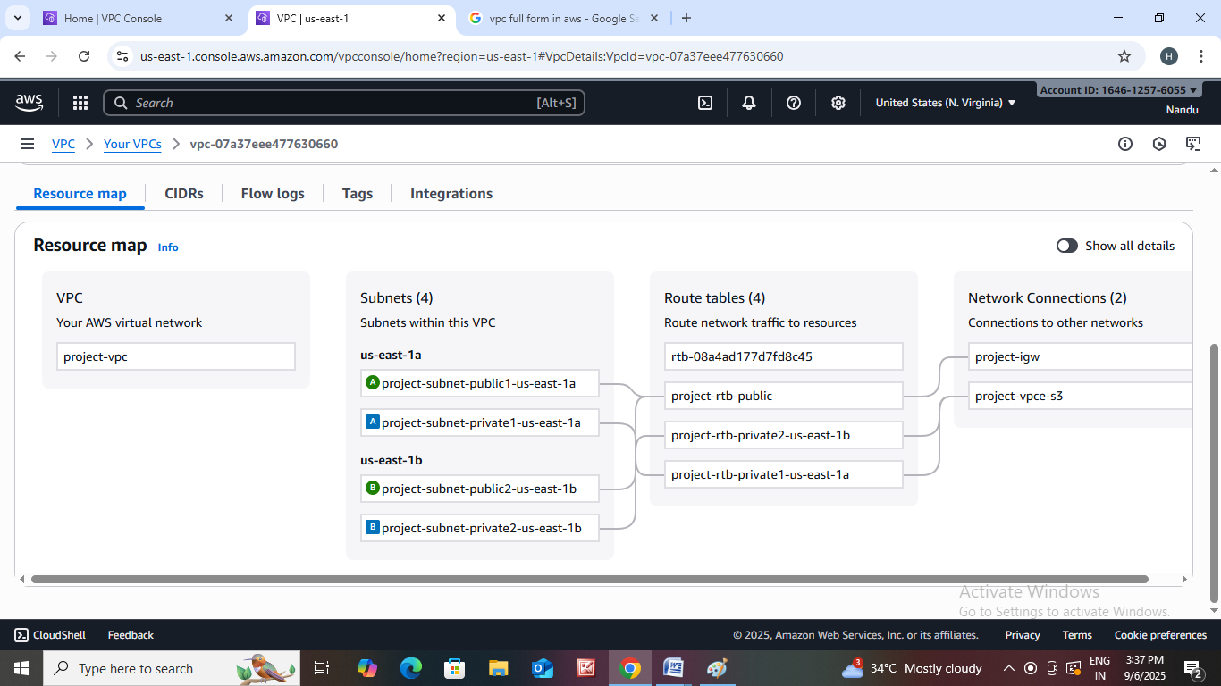

Let us create EC2 instance.

* Go to EC2 instance then click on launch instance.
* Then the page is open .
* Name : myserver
* Choose image and instance type.
* Create new key pair.
* In network settings click on edit.
* Select your VPC and Subnet .
* Enable Auto-assign public Ip.
* Then click on create instance.